Online Venue Management System

Technical Design Document

Table of Contents
1.0 Introduction 3
1.1 Purpose of this document 3
1.2 Project overview 3
2.0 Solution Summary 4
2.1 Scope 4
2.2 Assumptions 4
2.3 Dependencies 4
3.0 Schematic Diagram 4
4.0 System Design 6
4.1 Proposed design 6
4.2 Component inventory 6
5.0 Database Design 7
5.1 Data Model 7
5.2 Tables Structure 8
6.0 Appendices 11
6.1 Glossary 11
6.2 Other 11
7.0 Terms & Conditions 11
8.0 Change Log 11

Introduction

Purpose of this document
The purpose of this document is to document the technical design, component details and Database design. This will also capture the scope, assumptions, risk, dependencies of this project.

Project overview
OEMS (Online Event Management system) is an application for users and organizers for making process of managing events online and in simple way. In which, anyone who wants to book event at various available venues or who wants to list his or her property as venue can register. It provides ease in booking events at any venue as per users wish and it is completely online. Event Management is one of the most important things which will be carried out by event organizers. There are various events that can be organized by organizers for their customers. Once a user logs in he or she can check the available venues, check cost of each venue, food items and equipment provided by the organizers or venue owner, book event at venue and can make payments online. On the other hand, organizers can keep records of events booked on their venue. Whenever user deal with an event booking in manual way, he or she has very limited options with him or her and may miss the best prices and services offered by various organizers. One of the objectives of our project is to provide transparency while booking event online by providing all information about venue and standard costs of various elements to the user and maintaining equal standards for all venues. The user using the online event management service would be given user id after registration by the system. By using login password, the customer can login to the system and he or she can maintain his or her dashboard, view notifications, booking history, payment details etc.

Solution Summary

Scope
Online Event Management System can register Users and Organizers in the system and make easier to view the information related to the bookings, venues, food items and equipment.
1.User/Organizer registration, User/Organizer login and admin login credential authentication.
2. User/Organizer need to fill required attributes to register.
3.Admin can add and maintain food items and equipment information.
4.Admin can view all user, organizer, booking and venue details.
5.User can view venue, food item and equipment details.
6.User can book event, make payment, view booking history and notifications.
7.Organizer can add and maintain venue details and see event details booked for venue.

Assumptions
The login credentials of the admin will be stored in database itself. When booking is done and the payment is made then actual implementation of this service is not done, it is assumed to be made by external third-party application. To maintain same standards for all venue and to avoid complexities it is assumed that the food items and equipment will be common for all venues and it is maintained by the admin only. Notifications will be auto generated and send to respective user or organizer when particular actions performed by the user. Users can not book events if particular venue is already booked for that day.

Dependencies
- MS SQL Server 2018 needed for the database operations.
- Eclipse EE IDE software used to build and run the application.

Schematic Diagram
A schematic, or schematic diagram, is a representation of the elements of a system using abstract, graphic symbols rather than realistic pictures. It gives an overview of overall system.

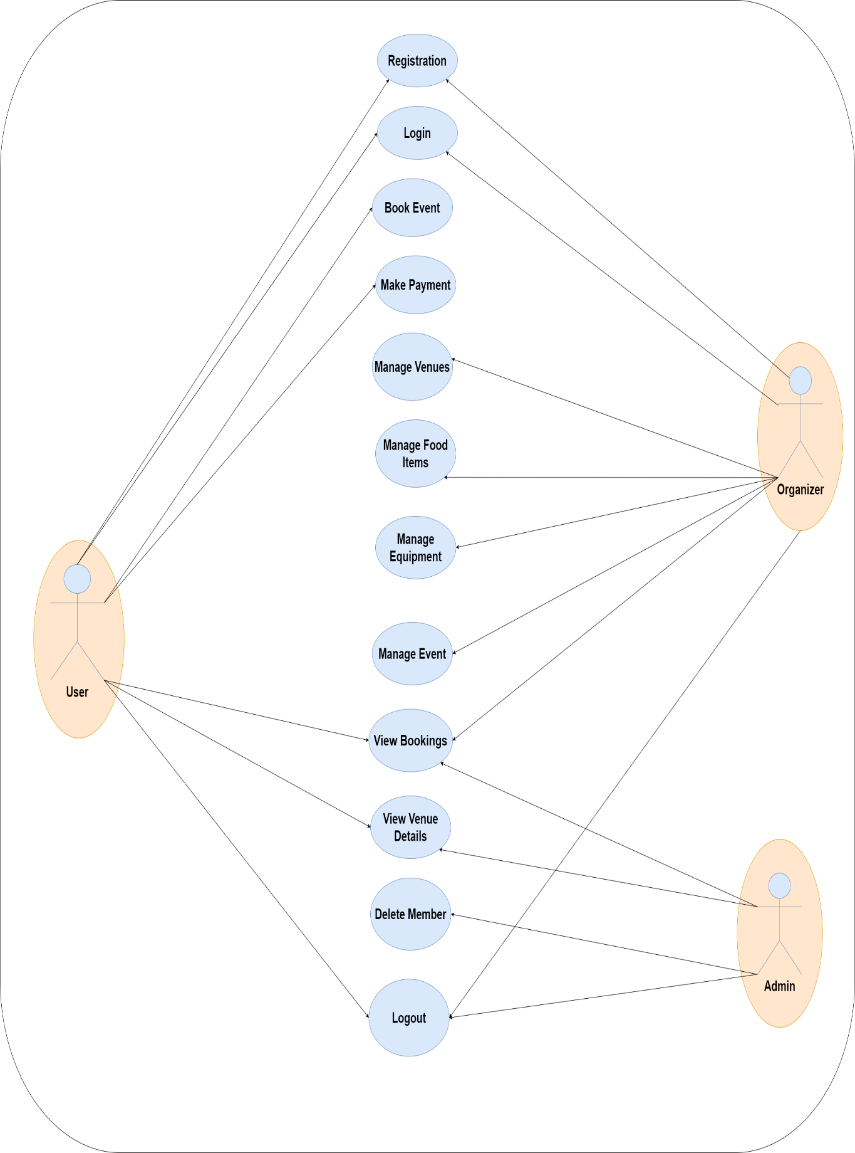

System Design

Proposed design
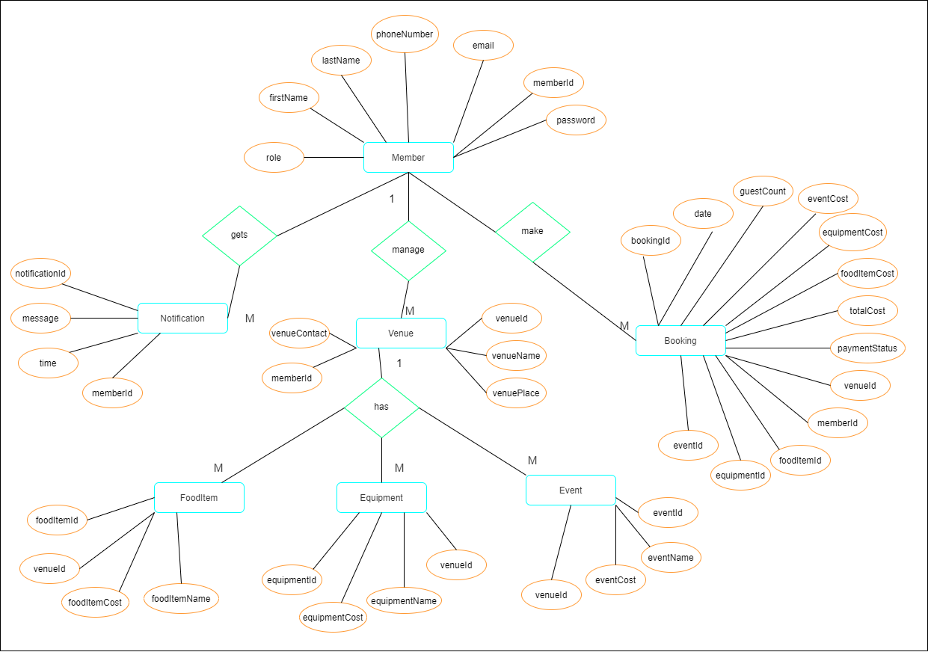

Component inventory

Model classes
- Members.java
- Booking.java
- Venue.java
- FoodItem.java
- Equipment.java
- Notification.java

Class Diagram

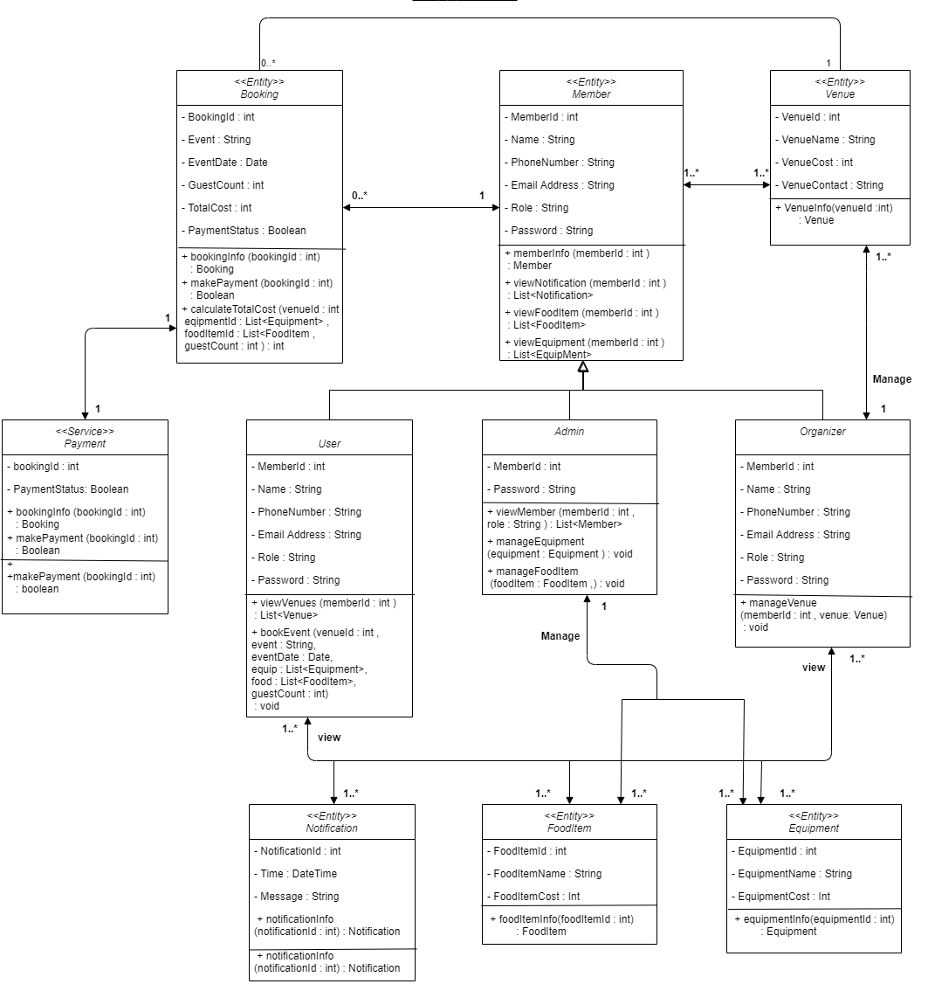

Design

Data Model

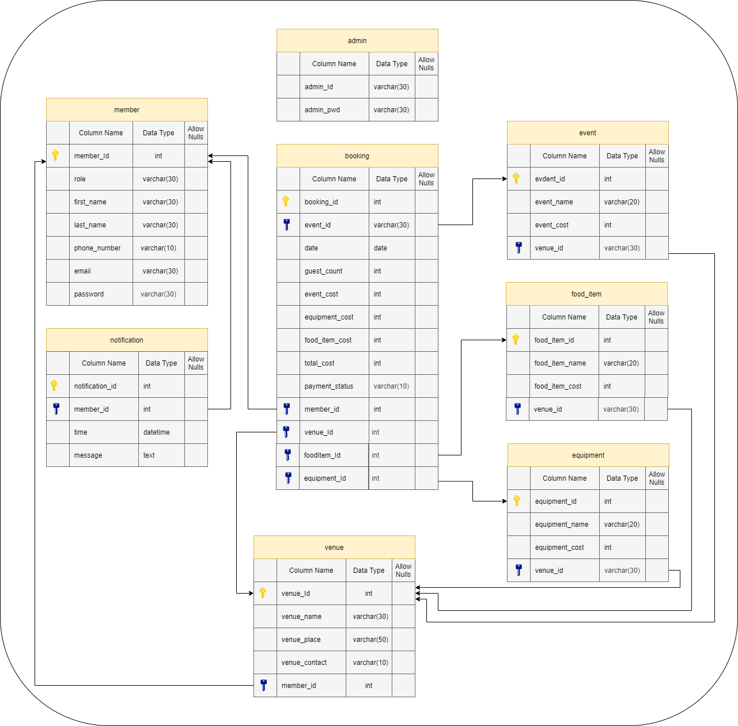

Tables Structure
Admin
Field Name | Field Type | Data Type | Mandatory | Possible Values
admin_id | Text | varchar | Yes | Pre-loaded
admin_pwd | Text | varchar | Yes | Pre-loaded

Members
Field Name | Field Type | Data Type | Mandatory | Possible Values
member_id | Numeric | int | Yes | Autogenerated
member_type | Drop Down | varchar | Yes
first_name | Text | varchar | Yes
last_name | Text | varchar | Yes
phone_number | Text | varchar | Yes
email | Text | varchar | Yes
password | Text | varchar | Yes

Venues
Field Name | Field Type | Data Type | Mandatory | Possible Values
venue_id | Numeric | int | Yes | Autogenerated
venue_name | Text | varchar | Yes
venue_place | Text | varchar | Yes
venue_cost | Numeric | int | Yes
venue_contact | Text | varchar | Yes
member_id | Numeric | int | Yes

Bookings
Field Name | Field Type | Data Type | Mandatory | Possible Values
booking_id | Numeric | int | Yes | Autogenerated
event_type | Drop Down | varchar | Yes
event_date | Date | date | Yes
guest_count | Numeric | int | Yes
venue_cost | Numeric | int | Yes
equipment_cost | Numeric | int | Yes
food_item_cost | Numeric | int | Yes
total_cost | Numeric | int | Yes
payment_status | Text | varchar | Yes
member_id | Numeric | int | Yes
venue_id | Numeric | int | Yes
foodItem_id | Numeric | int | Yes
equipment_id | Numeric | int | Yes

Equipment
Field Name | Field Type | Data Type | Mandatory | Possible Values
equipment_id | Numeric | int | Yes | Autogenerated
equipment_name | Text | varchar | Yes
equipment_cost | Numeric | int | Yes

Food_Items
Field Name | Field Type | Data Type | Mandatory | Possible Values
food_item_id | Numeric | int | Yes | Autogenerated
food_item_name | Text | varchar | Yes
food_item _cost | Numeric | int | Yes

Notifications
Field Name | Field Type | Data Type | Mandatory | Possible Values
noti_Id | Numeric | int | Yes | Autogenerated
member_id | Numeric | int | Yes
time | Date | datetime | Yes
notification | Text | text | Yes

Appendices

Glossary
Acronyms | Definitions
OEMS | Online Event Management System

